**Check in:** The kids have started to go back to school. Check in with them on how the first days of going back to school in person and online have been. See if they have anything that they are confused about or need help with. Feel free to take some time with this.

**Warmer**: show and tell

* Tell the students to go get something that is very special to them.
* Ask the students some follow up questions. Ask each student 1-2 questions. Try to make the questions different among the students.
* Why do you like ____? When did you get it? Why is it special? Who got it for you? Where did you get it? How long have you had it?......

**Homework help**: Ask the students to share their screen and show you what they are working on. If you are having trouble getting the students to share below are some questions you can ask to stimulate the conversation on what they are learning and what they may need help on.

Ask questions like:

* What homework did you have this week?
* Can you show me you English/math/ history…?
* Can you tell me about what you did in history/English/ math/ science this week?
  + Can you explain it to me?

**Brain break game**: red light green light

* Students turn on their cameras. In the chat they start sending one number at a time. 1 send 2 send 3 send ….
* The coach holds up something red. Students must race to turn off their cameras and stop typing.
* When the coach holds up something green students turn on cameras and continue to type the numbers 4 send 5 send 6 send……
* Coach continues to hold up red or green things. If a student does not stop typing or does not turn off their camera they have to start again at the number 1.
* To will the first student to get to the number the coach tells them is the winner.

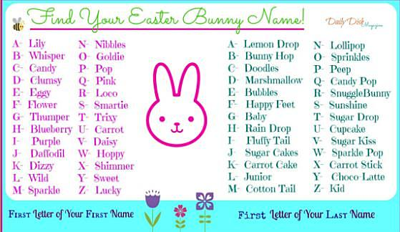OR

What is your Easter bunny name?

**Review Fractions:** <https://www.khanacademy.org/math/cc-fifth-grade-math/imp-fractions-3>

Review Questions: <https://www.khanacademy.org/math/cc-fifth-grade-math/imp-fractions-3/imp-visually-adding-and-subtracting-fractions-with-unlike-denominators/e/using-visuals-to-add-and-subtract-fractions-with-unlike-denominators-?modal=1>

<https://www.khanacademy.org/math/cc-fifth-grade-math/imp-fractions-3/imp-visually-adding-and-subtracting-fractions-with-unlike-denominators/e/estimate-to-add-and-subtract-fractions-with-different-denominators?modal=1>

Feel free to review fractions some and play the Kahoot! Games.

Kahoot! Games:

* <https://kahoot.it/challenge/05330862?challenge-id=e21d906a-1678-4c6e-a9ee-5f26c1dc0f29_1614965677932>
  + PIN: **05330862**
* <https://kahoot.it/challenge/05064832?challenge-id=e21d906a-1678-4c6e-a9ee-5f26c1dc0f29_1615310284572>
  + PIN: **05064832**

**Games**: What will you do for spring break?

* Are you going back to school in person?
* Do you like it?

**Wrap up** finish working on what you are working on or transition to the game.